Building back ~~better~~ *Unbreakable*

Resilience depends on the speed and quality of recovery

Abstract: Tracking estimates of resilience is key to understanding the ability of countries to withstand natural shocks. Following on the World Bank’s Unbreakable report, this study provides an update to the resilience indicator based on the latest available data. It shows that overall countries have made some progress in building resilience since the previous estimates. Further, this report shows that by estimating this resilience indicator, several of the main drivers of vulnerability and resilience can be determined – and thus resilience building measures can be identified and prioritized. This report considers different measures under the “building back better” principle: Faster, more inclusive, and stronger reconstruction.

# Building back better

Allowing no respite to people across the Caribbean in late 2017, Hurricane Irma was followed within few days by Hurricane Maria – both of which reached the highest intensity storm category. They wreaked destruction on numerous small islands, causing severe damages on islands like Barbuda and Saint Martin. The human cost of these disasters is immense. Many lives were lost, even though early warning systems and timely evacuations were able to save many more. And many survivors have lost lifelong savings, homes, and livelihoods. Destruction in the infrastructure and residential sectors is likely to exceed 100 percent of GDP on several islands. 70 to 80 percent of Dominica’s houses and buildings sustained major storm damages, ranging from ripped off roofs to total destruction. Entire regions have lost access to basic services, such as electricity and safe drinking water, and some remote communities were cut off completely for days. Returning to normalcy will take months, if not years, and for vulnerable people – especially children and elderly – the next months are a critical period, with the heightened risk of mortality and permanent effects on children’s education and health.

And the risk of further hurricanes remains high: the Caribbean hurricane season extends from the beginning of June through the end of November each year. In addition, it is evident that these recent disasters took place in the context of increasingly frequent and intense extreme weather events – a trend that is by no means limited to the Caribbean, as other regions of the world, from Sierra Leone to Bangladesh, have been heavily affected in recent months. Continued urbanization and population growth, especially in coastal areas, as well as climate change are bound to magnify these trends in the next decades.

Considering these trends, the destruction caused by disasters highlights the need, but also the opportunity to *build back better*. Reconstruction offers an opportunity to build more resilient societies that are1 able to withstand future shocks by better managing the risks they face: with new buildings located outside flood zones and with structures designed to resist high winds; roads, bridges, and electric grids that are able to endure the next storm; and human settlements that provide a better quality of life and enable higher productivity.

This study builds on the framework and model described in the *Unbreakable* report to investigate the potential benefits from building back better after disasters. We look into three three key aspects of building back better, showing that they can all contribute to major reductions in the well-being impacts of natural disasters:

* *Building back faster*. Results show that shorter recovery and reconstruction periods mean that societies are ready for future disasters sooner. If the average recovery speed is reduced by two third, global well-being losses could be reduced by 13%, which is equivalent to increasing global consumption by almost $75 billion per year. These gains are especially large in countries with frequent events, such as small island countries or Sub-Saharan countries.
* *Building back more inclusively,* i.e. ensuring that post-disaster support reaches all affected population groups without bias. This emphasizes the importance of providing recovery support to low-income households who are typically more exposed, more vulnerable, and less supported. If all countries had the ability to support the poorest people with post-disaster support, global well-being losses due to natural disasters could be reduced by 3.7%, equivalent to a $20 billion increase in annual global consumption. The effect is particularly large in countries with large inequality and where poor people have little access to social protection and financial instruments. In Benin, Zambia, Antigua & Barbuda, Malawi, Haiti, Coast Rica, El Salvador, Greece, Argentina and Kenya, building back more inclusively would reduce disaster losses by more than 12 percent.
* *Building back stronger* can help to reduce well-being losses by ensuring that reconstructed infrastructure can resist more intense events in the future. If all countries would “build back *stronger*” during a 20-year time window, ensuring that reconstruction can resist the 50-year return period hazards, then global well-being losses due to natural disasters would be reduced by 11.7% from US$ 560 bn to US$ 494 bn annually. *Stronger* recovery could reduce overall well-being losses due to natural disasters by more than 33 percent in nine countries: Tonga, Guatemala, Peru, Trinidad and Tobago, Fiji, Greece, Haiti, Vietnam and Chile.

Taken together, these three actions – rebuilding faster, more inclusively, and stronger – could generate large benefits, totaling $XX billion per year, that is YY percent of current disaster losses. Building back better is particularly important in small island countries, due to their large current vulnerability and small scale. In the AA small island countries included in this analysis, it would lead on average to a reduction by PP percent of disasters losses.

To reach these conclusions, the first section of this study provides an update to the estimates of resilience provided in the Unbreakable report, based on the latest available data. It also expands the analysis from 117 to 151 countries. It shows that many countries have been able to strengthen their socio-economic resilience in the past two years, while others have experienced a reduction in resilience. By focusing on the cases of four selected countries, this report also discusses the factors that determine changes in resilience. The second section provides an analysis of the role of ‘building back better’ – i.e. the way in which speed and quality of post-disaster recovery determines socio-economic resilience to disasters, looking into the three dimensions: Building back *faster*, *more inclusively*, and *stronger*.

# Beyond asset losses: The well-being losses of natural disasters depend on people’s socio-economic resilience

Frequently, the estimated losses due to natural disasters focus only on damages to assets – including buildings, infrastructure, equipment, and production. According to such estimates, 2017 was the costliest year on record in terms of weather-related natural disasters. From hurricanes and wildfires to droughts and floods, global economic losses totaled more than $330 billion (Munich Re).

However, as highlighted in the *Unbreakable* report (Hallegatte et al., 2016), the focus on asset losses fails to inform us how disasters affect people’s well-being. The report highlighted that the overall well-being impact of a disaster depends critically on the impact of asset losses on income and consumption along the recovery and reconstruction phase. For example, the same asset losses have different impacts depending on whether reconstruction takes place over a few months or several years.

The impact on well-being also depends on who is affected. Clearly, a $1 loss is experienced differently by a rich person than by a poor person. The same loss affects poor and marginalized people far more because their livelihoods depend on fewer assets, their consumption is closer to subsistence levels, they cannot rely on savings to smooth the impacts, their health and education are at greater risk, and they may need more time to recover and reconstruct.

To account for this important difference between asset and well-being losses, the *Unbreakable* report developed a new resilience metric measuring how natural disasters affect people’s well-being. Classically, it accounts for the exposure and vulnerability of people, i.e., on how often they are affected and how much of their assets are lost when they are affected. But the framework also includes their socio-economic resilience, defined as their ability to cope with a disaster, receive support, and recover and reconstruct (Figure 1).

By examining well-being instead of asset losses, the report provided a deeper (and grimmer) view of natural disasters than does the usual reporting—indeed, this view takes better account of poor people’s vulnerability. But, in doing so, the report also highlights new opportunities for interventions to minimize disaster losses by reducing the specific vulnerability of poor people, for instance through appropriate targeting of social expenditures or improved access to financial instruments, from saving accounts and borrowing to insurance.

**Figure 1.** People's well-being losses due to a disaster depend on their resilience, i.e. their ability to cope, receive support, and recover.

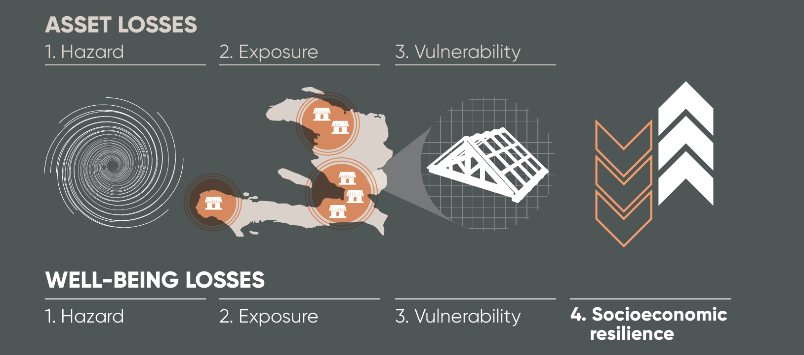

In all of the 117 countries studied in the report, well-being losses from natural disasters are larger than asset losses (Hallegatte, Bangalore, and Vogt-Schilb, 2016). According to the *United Nations Global Assessment Report on Disaster Risk Reduction*—the so-called GAR (UNISDR 2015)—total asset losses from natural disasters in these countries average $327 billion a year.[1] Because disaster losses are concentrated on a small share of country populations, imperfectly shared, and affect more poor people (who have limited ability to cope with them), this report estimates that well-being losses in these countries are equivalent to consumption losses 60 percent larger than asset losses, or about $520 billion a year.

**Box 1. Quantifying socioeconomic resilience and well-being losses**

Based on the resilience model presented in the Unbreakable report, this update report calculates the risk to well-being by considering the four drivers of the loss in well-being as described above: natural hazards, exposure, vulnerability, and socio-economic resilience. Specifically, s*ocio-economic resilience* is defined as the ratio of *asset* losses to *well-being* losses:

$$\text{socio-economic resilience}=\frac{\text{asset losses}}{\text{well-being losses}}$$

Based on this definition, socio-economic resilience is considered a driver of the risk to well-being along with the three usual drivers: hazard (the probability an event occurs), exposure (the population and assets located in the affected area), and asset vulnerability (the fraction of asset value lost when affected by a hazard):

$$\text{risk to well-being}=\frac{\text{expected asset losses}}{\text{socio-economic resilience}}=\frac{\text{hazard * exposure * asset vulnerability}}{\text{socio-economic resilience}}$$

The *Unbreakable* report used this approach to quantify the risk to well-being in 117 countries, based on the latest available data in 2016. It calculated asset and well-being losses for multiple hazards, considering return periods from 2 to 1,500 years: River floods, coastal floods due to storm surge, windstorms, earthquakes, and tsunamis. Socio-economic resilience was then estimated as the ratio of expected asset losses to expected well-being losses.

Resilience to natural disasters is never constant and depends on a wide range of dynamic factors. Such factors include changing exposure due to population growth and rapid urbanization, intensifying hazard levels due to climate change, or strengthened ability to cope and recover due to effective disaster risk management. To understand how resilience to natural disasters is evolving in countries around the world, these wide-ranging factors must be tracked and evaluated continuously.

This section follows up on the Unbreakable report and updates the computation of its resilience indicator using the latest available data on socio-economic trends. More specifically, updated data include economic activity (GDP), urbanization, income inequality, level and coverage of social protection schemes, and sovereign credit ratings (which determine a country’s ability to access credit in the case of a contingency).

Of course, any indicator is only as good as the data it is based on, and the uneven pace at which new data becomes available implies that different variables in different countries are updated at different times. Measures of income inequality, for instance, are based on household surveys that are typically not conducted annually. While the updated resilience indicator in this report is based on the latest available data, not all variables in all countries will have been updated. Since data updates occur at different times for different countries, any comparison of across countries should be made with caution. The resilience indicator and its subsequent updates primarily serve the purpose of tracking the resilience of individual countries across time.

Based on the model used in the Unbreakable report with a few minor changes, and using the latest available data in 2018, the updated estimated socio-economic resilience indicator displays a similar pattern to the earlier estimates (Figure 2). Countries with higher average incomes tend to be more resilient than lower income countries.

At the same time, resilience levels in low-income countries have a large variance, thus indicating the importance of factors other than income in determining resilience. Risk to assets, expressed as a share of GDP, is also estimated to disproportionately affect low-income countries (Figure 3). High-income countries tend to have risks to assets of below 1% of GDP, while for low income countries the variance increases to an upper bound of almost 10% of GDP.

The risk to well-being, measured as a share of GDP, is also particularly high in low-income countries (Figure 4). Globally, annual average well-being losses are estimated to be US$ 560 bn for the 150 countries included in this analysis.

**Figure 2**. Socio-economic resilience to natural disasters. Grey markers refer to 2015 data and orange to 2017.

**Figure 3** Risk to assets as a share of GDP. Grey markers refer to 2015 data and green to 2017.

**Figure 4** Risk to well-being as a share of GDP. Grey markers refer to 2015 data and blue to 2017.

## Country focus

When looking at individual countries,

**Figure 5** Percentage change in resilience and GDP per capita between 2015 and 2017

**Figure 6.** Parameter changes in Mauritania from 2015 to 2017.

# Resilient recovery: Building back better

## Building back *faster*

The speed of recovery after a disaster depends strongly on the level of preparedness and resources available for a quick and resilient recovery. Especially in countries that are hit frequently by natural shocks, a fast recovery is critical to ensure that people, assets, and infrastructure are prepared to withstand the next shock. This is the case, for instance, in small island states that experience intense tropical hurricane or cyclone seasons each year, and need to ensure that damages from one storm are repaired quickly enough to not compromise the ability to withstand the next.

The results presented in this section show that faster recovery can significantly reduce the average well-being losses due to natural disasters. With an average recovery speed of five years, global well-being losses would be US$ 631 bn. With our “best guess” of an average reconstruction duration of 3 years, losses decrease to US$ 560 billion. And if the average recovery speed is reduced to one year, global well-being losses could be reduced to US$ 485 bn (Figure 11). Figure 7 shows the reduction in average well-being losses due to faster recovery for the ten countries with the largest absolute losses.

**Figure 7** Global reduction well-being losses associated with different recovery durations

**Figure 7** Reduction in average well-being loss due to faster recovery for the top ten countries in terms of losses: The top point refers to the well-being loss associated with a five-year reconstruction period, while the bottom point refers to a one-year reconstruction period. Percentages indicate the reduction in well-being losses by speeding up recovery from five years to one.

As suggested above, the importance of ‘building back faster’ differs across countries. Countries that experience high impact shocks at relatively low return periods – i.e. frequent large shocks – are bound to benefit most from accelerated recovery. Figure 9 presents the ten countries with the largest relative reduction in well-being losses due to faster recovery. In addition, Figure 10 provides a global overview illustrating that the countries that benefit most from faster reconstruction tend to be lower income developing countries.

**Figure 9** Top ten largest reductions in average well-being losses due to faster recovery

**Figure 10** Percentage reduction of well-being losses associated with faster recovery (reduced from five years to one). Countries are sorted in quartiles (i.e. same number of countries for each colour).

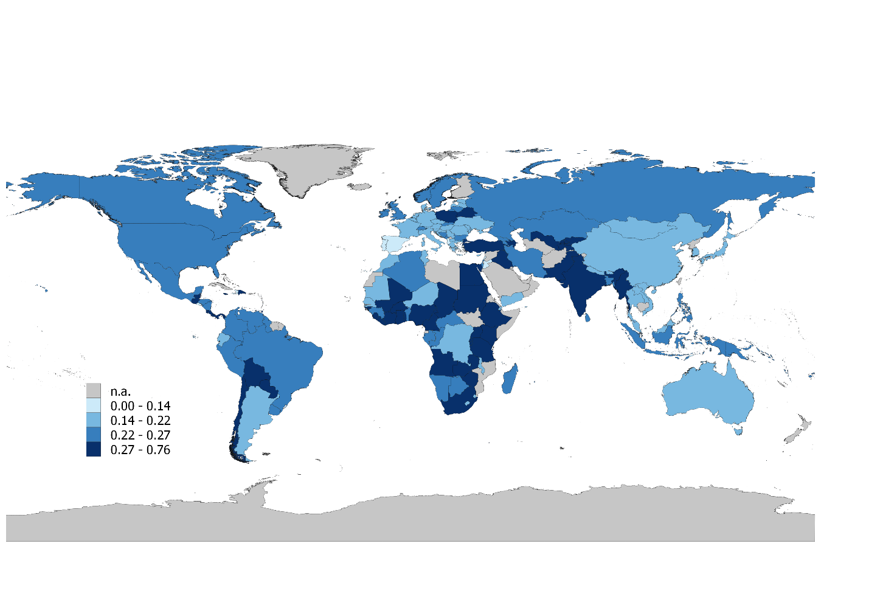

Since building back better has been discussed after the last hurricane season in the Caribbean, it’s interesting to focus on small island states. Figure 8 presents the reduction in average well-being losses due to faster recovery for ten selected small island developing states. Unsurprisingly, small islands are among the countries where the impact of rebuilding faster is the biggest: the reduction is 32% on average, compared to 23% globally. Measures to accelerate recovery can even halve the annual well-being losses in Trinidad and Tobago.

**Figure 8**: Reduction in average well-being loss due to faster recovery for ten selected small island developing states: The top point refers to the well-being loss associated with a five-year reconstruction period, while the bottom point refers to a one year reconstruction period. Percentages indicate the reduction in well-being losses by speeding up recovery from five years to one.

## Building back *more inclusively*

As the Unbreakable report has shown, poor people are not only more exposed and more vulnerable to natural hazards, but they also tend to have access to fewer post-disaster support mechanisms, such as insurance, borrowing, or remittances. They also have less savings to mobilize. As a consequence, they tend to experience larger losses relative to income and have relatively fewer means at their disposal to manage their recovery.

Without dedicated actions to ensure that post-disaster support measures reach poor people, these support measures are likely to disproportionately benefit higher income recipients. One reason, for example, could be the lack of financial inclusion, which means that poor people tend to lack access to bank accounts and thus formal channels of receiving cash transfers from social safety net schemes.

In this context, “building back *more inclusively*” means that recovery measures ensure that inequalities are reduced – especially with regards to the access to post-disaster support and social safety nets. This means that all affected population groups are supported, with special effort made to meet the needs of low-income households. Particularly in countries with high inequality, *more inclusive* recovery can increase overall resilience by ensuring that poor people – i.e. the most exposed, most vulnerable and least supported – have access to the post-disaster support they require. For instance, this could take the form of strengthened social safety nets with better targeting mechanisms.

The distribution of post-disaster support will also depend on how the transfer amounts are calculated. In “insurance-like” systems where the support is proportional to the amount of losses, like in Vietnam, richer individuals tend to receive more (because they are losing more). In the presence of strict spending constraints, it also often means that people are covered for only a small fraction of their losses. Poor people tend to receive large amounts with systems where all affected people receive the same amount – like in Fiji after Tropical Cyclone Winston, see Government of Fiji and World Bank (2017).

For the sake of illustration, the estimates in this section assume that recovery measures result in “perfect inclusiveness”, i.e. that all affected households have access to post-disaster support regardless of their pre-disaster income level, and all receive the same amount, regardless of their wealth and losses. The estimates suggest that if all 151 countries rebuilt more inclusively, global well-being losses due to natural disasters could be reduced by 3.7% from US$ 560 bn to US$ 539 bn annually.

Figure 12 provides an overview of the countries in which more inclusive recovery would lead to the largest reduction in average well-being losses. The estimates show that inclusive recovery could reduce overall well-being losses due to natural disasters by up to 19%. Inclusive recovery tends to be particularly effective in lower-income developing countries, countries with high inequality, and countries with low sovereign credit ratings (which affects their ability to borrow and finance post-disaster support measures). However, in high-income countries more inclusive recovery shows little benefit – mainly because social protection systems are already relatively well-equipped to target and support even the lowest income groups. Moreover, Figure 13 shows that “building back *more inclusively*” tends to yield higher reductions in well-being losses in countries with high pre-existing inequality.

**Figure 12** Top 10 largest reductions in average well-being losses due to more inclusive recovery

**Figure 13** The benefits of more inclusive recovery depend on the level of pre-existing income inequality

## Building back *stronger*

Reconstruction phases represent rare opportunities to reduce the vulnerability of affected regions and countries. Hence, “building back better” must not only mean *faster* and *more inclusively*, but also *stronger*.

This principle refers in particular to resilient reconstruction that strengthens the ability of assets to withstand natural shocks. For instance, the large scale physical destruction experienced in 2017 by several Caribbean island states (including Dominica and Antigua & Barbuda) offers the opportunity to ensure that destroyed assets are reconstructed to more resilient standards – i.e. that they can withstand more intense events in the future.

To estimate the benefits of “building back *stronger*”, we assume that destroyed assets are reconstructed to a resilience standard that is able to withstand shocks up to a 50-year return period.[2] The estimates suggest that if all countries would “build back *stronger*” during a 20-year time window, then global well-being losses due to natural disasters could be reduced by 11.7% from US$ 560 bn to US$ 494 bn annually.

Figure 14 provides an overview of the countries in which *stronger* recovery would lead to the largest reduction in average well-being losses. The estimates show that *stronger* recovery could reduce overall well-being losses due to natural disasters by more than 33 percent in nine countries: Tonga, Guatemala, Peru, Trinidad and Tobago, Fiji, Greece, Haiti, Vietnam and Chile.

**Figure 14** Top 10 largest reductions in average well-being losses due to "building back stronger".

These estimates illustrate that post-disaster reconstruction offers an opportunity for implementing resilience standards and reducing losses from future events. However, this also implies that the same argument applies to all new infrastructure construction, regardless of whether a disaster occurred recently. Especially developing countries are already in the process of rapidly developing their infrastructure in response to population growth, urbanization, and economic growth. In order to avoid increasing exposure and vulnerability, all of these infrastructure investments must take into account natural hazards and risks.

# Tracking progress in resilience

Regular updates will help to understand progress made and the prioritization of resilience building measures.

1. This number cannot be directly compared with the $330 billion in losses that occurred in 2017, because the GAR estimates include small scale disasters that are not recorded in global loss databases.
2. A time frame of 20 years is chosen for this purpose: Every asset destroyed by a natural disaster within a 20-year time frame is reconstructed to the new standard. The estimated reduction in well-being losses are the amount that can be achieved at the end of this time frame.